2025 MISION MATH MISSION MATH UTAH SPRING COMPETITION (GRADES 1 AND 2)

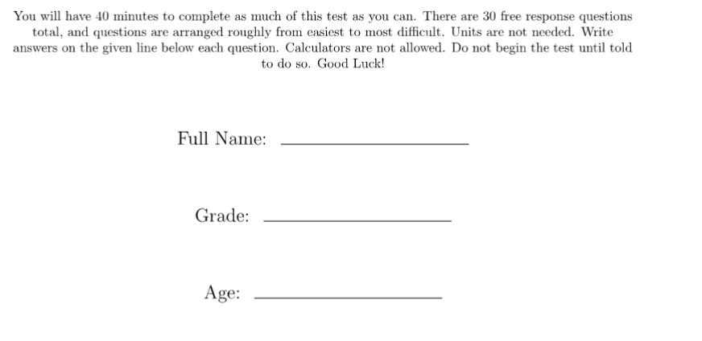

- 9 Animals
- 10
- 15 chairs
- 17
- 4 students
- 4
- 9 feet
- ⅛
- 9 stickers
- 11 boats
- 6 feet
- 9 inches
- 2 ⅗
- 12 quarters
- 87 students
- ⅙
- 3 ways
- 32
- 112 pages
- 8 units^2
- 2
- 5/12
- 16
- $16
- 6
- 20 units
- 4π in^2
- 2
- 96 pages
- 5th

